**Introduction**

Amazon Virtual Private Cloud (Amazon VPC) enables you to launch AWS resources into a virtual network that you've defined. This virtual network closely resembles a traditional network that you'd operate in your own data center with the benefits of using the scalable infrastructure of AWS. It is logically isolated from other virtual networks in the AWS cloud.

You can create a new VPC using the AWS Management Console.

**Instructions**

1. Click **Services** at the top of the AWS Management Console. Type *vpc*into the search field and select **VPC**:

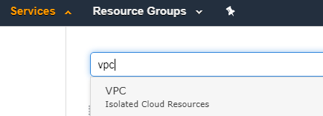

2. From the VPC dashboard, click on **Your VPCs** link in the sidebar menu:

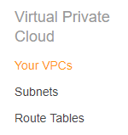

 Thispage lists all previously created VPCs. Every new AWS account comes with a **Default VPC**.

3. Click **Create VPC**to begin creating a new VPC:

alt

4. Specify the following VPC details on the Create VPC page then click **Create:**

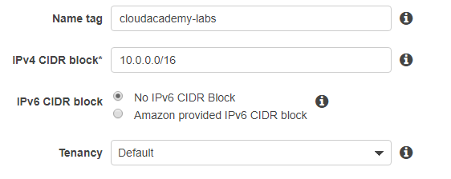

* **Name tag**: cloudacademy-labs. This is the name for your VPC; doing so creates a tag with a key of Name and the value that you specify.
* **CIDR block**: 10.0.0.0/16. You should specify a CIDR block from the private (non-publicly routable) IP address ranges as specified in RFC 1918.
* **IPv6 CIDR block**: No IPv6 CIDR block. VPCs support IPv6 addresses but this is not a focus for this Lab.
* **Tenancy**: default. Dedicated tenancy ensures your instances run on single-tenant hardware.

5. Click **Close** on the confirmation page that follows:

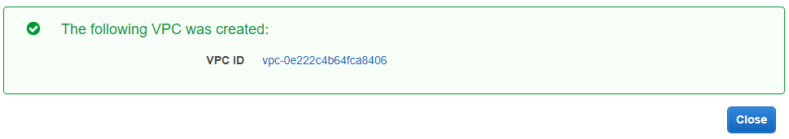

Amazon creates the requested VPC and the following linked services:

* a **DHCP options set** (this set enables DNS for instances that need to communicate over the VPC's Internet gateway)
* a **Route Table**(it contains a set of rules, called *routes*, that are used to determine where network traffic is directed)
* a **Network ACL**(it is a list of rules to determine whether traffic is allowed in or out of any subnet associated with the network ACL)

*Note:* No Subnets or Internet Gateways are automatically created -- you need to add them autonomously.

**Summary**

In this Lab Step, you created a VPC. In the following steps, you will create additional resources within the VPC.

**Introduction**

A VPC subnet is a range of IP addresses in your VPC. You can add one or more subnets in each Availability Zone, but each subnet must reside entirely within one Availability Zone and cannot span zones. Availability Zones are distinct locations that are engineered to be isolated from failures in other Availability Zones. By launching instances in separate Availability Zones, you can protect your applications from the failure of a single location.

You can create a new subnet for your previously created VPC using the AWS Management Console.

**Instructions**

1. From the VPC dashboard, click the **Subnets** link in the sidebar menu:

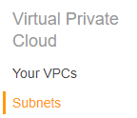

The Subnets page lists all previously created subnets. At this point, there are three automatically created default subnets associated with the default VPC. When you have many subnets, you can use the **Filter by VPC** feature for listing only the subnets linked to a specific VPC:

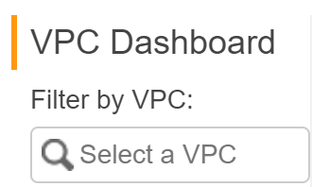

2. Click **Create Subnet**to begin creating a new subnet:

alt

3. In the **Create Subnet** form, specify the following Subnet details then click **Create**:

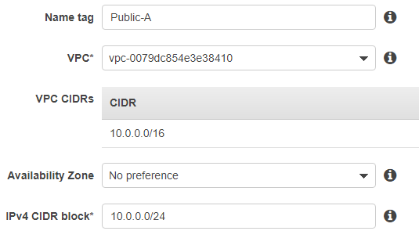

* **Name tag**: Public-A. This is the name for your subnet; doing so creates a tag with a key of Name and the value that you specify.
* **VPC**: cloudacademy-labs.
* **Availability Zone**: us-west-2a.
* **CIDR block**: 10.0.0.0/24. You should specify a CIDR block in the selected VPC.

4. Click **Close** on the confirmation page that follows:

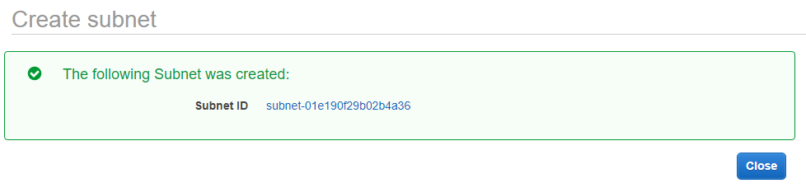

5. On the Subnets page, select the subnet you just created:

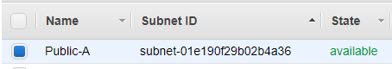

As you can see in the description tab at the bottom of the page, the created subnet is automatically attached to the default **Route table** and the default **Network ACL** for the **cloudacademy-labs** VPC:

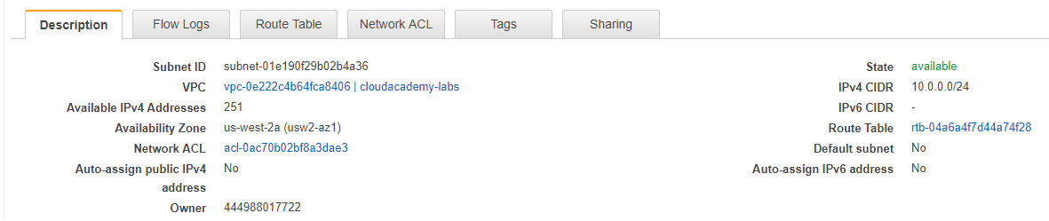

**Summary**

In this Lab Step, you created a subnet for your AWS VPC.

### Introduction

An internet gateway is a horizontally scaled, redundant, and highly available VPC component that allows communication between instances in your VPC and the Internet. It imposes no availability risks or bandwidth constraints on your network traffic. An internet gateway serves two purposes: to provide a target in your VPC route tables for internet-routable traffic and to perform network address translation (NAT) for instances that have been assigned public IP addresses.

You can create a new internet gateway for your previously created VPC using the AWS Management Console.

### Instructions

1. From the VPC dashboard, click the **Internet Gateways** link in the sidebar menu:

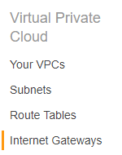

2. Click **Create Internet Gateway**to begin creating a new gateway:

alt

3. On the **Create internet gateway** form, enter labs-gw in the **Name tag** field and then click**Create**:

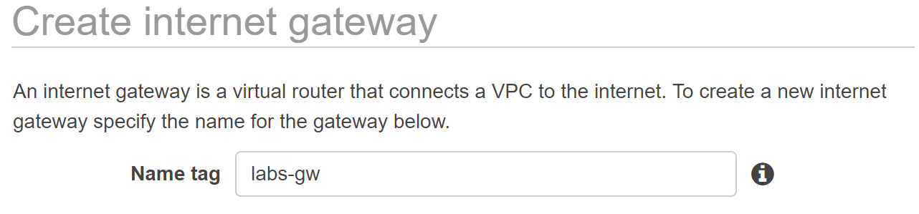

4. Click **Close** on the confirmation page:

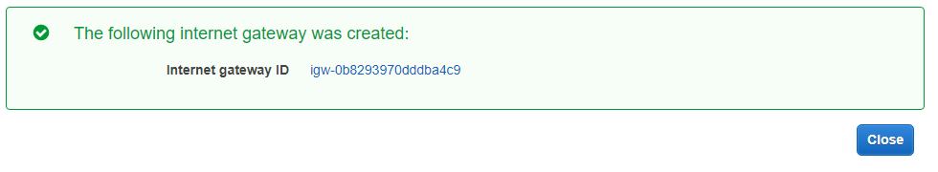

5. On the Internet Gateway page, select the internet gateway that you just created and click **Actions -> Attach to VPC**to attach to a VPC:

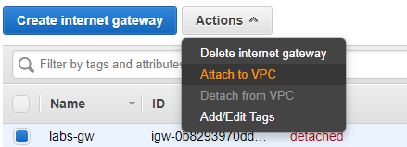

6. In the **Attach to VPC** page, select the VPC cloudacademy-labs from the list, and then click **Attach**:

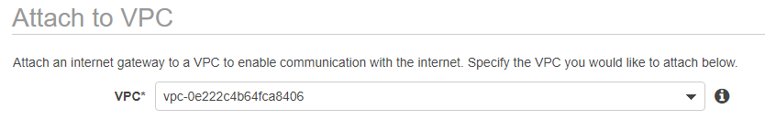

### Summary

In this Lab Step, you created an internet gateway for your VPC.

### Introduction

To use an internet gateway your subnet's route table must contain a route that directs internet-bound traffic to the internet gateway. You can scope the route to all destinations not explicitly known to the route table (0.0.0.0/0), or you can scope the route to a narrower range of IP addresses; for example, the public IP addresses of your company’s public endpoints outside of AWS, or the Elastic IP addresses of other Amazon EC2 instances outside your VPC. If your subnet is associated with a route table that has a route to an internet gateway, it's known as a public subnet.

You can add routes to your previously created VPC route table using the AWS Management Console.

### Instructions

1. From the VPC dashboard, click the **Route tables** link in the sidebar menu:

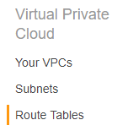

2. Select the **Main**route table for the cloudacademy-labs VPC:



3. Select the **Routes** tab:

alt

Routes are a set of rules which are used to determine where network traffic is directed.

4. Click the **Edit routes**button:

alt

5. Click **Add another route** and enter 0.0.0.0/0 as the **Destination** CIDR block. In the **Target** field, click **Internet Gateway** and then your previously-created internet gateway. Click **Save routes**:



This sets all external traffic for the main route table of your VPC to go through the internet gateway.Summary

In this Lab Step, you configured your VPC's main route table to route external traffic to the internet gateway, which enabled internet connectivity for your VPC.

**Introduction**

An Elastic IP address (EIP) is a static and public IP address that you can associate with an EC2 instance. EIPs have the benefit of not changing when you stop and start an EC2 instance, whereas the default public IP that comes with an EC2 instance may change. This gives you the benefit of a reliable IP address to associate with your EC2 instance. In this Lab Step you will allocate an EIP and associate it with your EC2 instance.

**Instructions**

1. Navigate to the [VPC dashboard](https://us-west-2.console.aws.amazon.com/vpc/home?region=us-west-2).

2. From the VPC dashboard, click on **Elastic IPs** link in the sidebar menu:

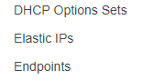

3. Click **Allocate Elastic IP address**and then click **Allocate**:

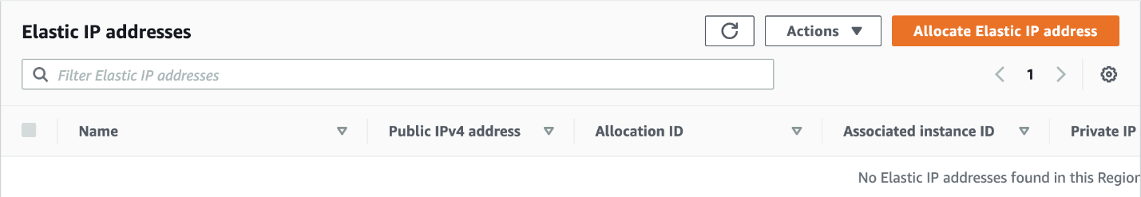

4. Review the newly-created EIP:

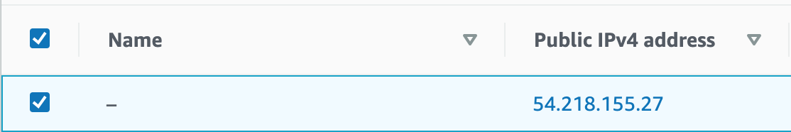

5. With the EIP still selected, click **Actions** > **Associate Elastic IP address**and then select the following values:

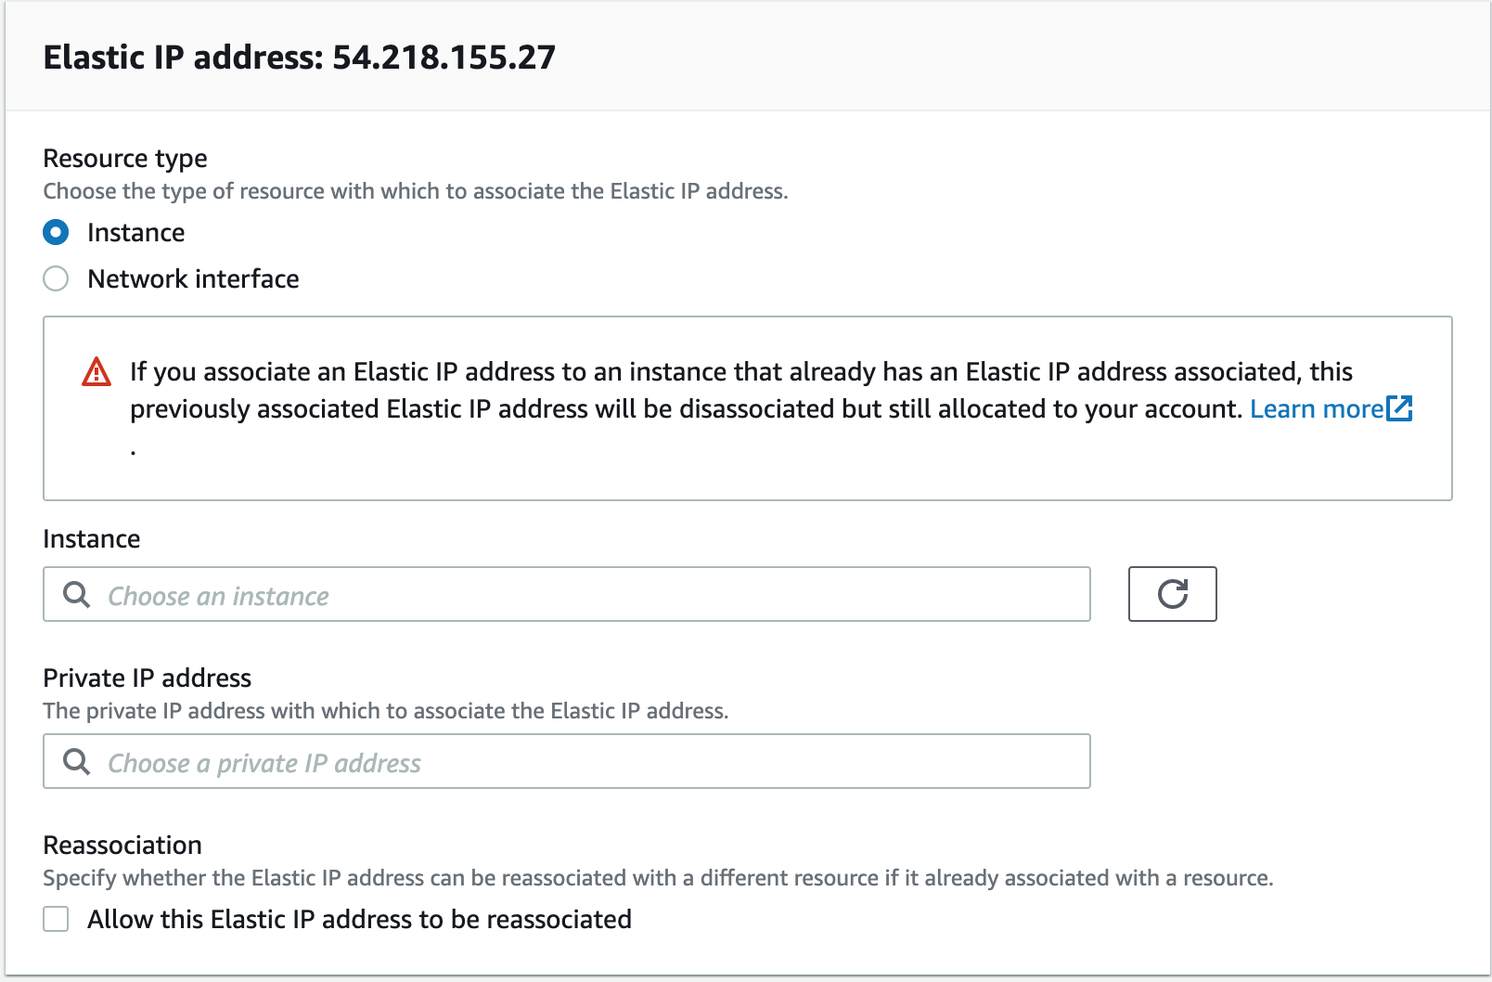

* **Resource type**: Instance
* **Instance**: Select the only instance from the drop-down list. It is the instance you created.
* **Private IP**: Leave this blank to have an available Private IP automatically assigned.

6. Click **Associate** to associate the EIP to the selected EC2 instance:



7. Click **Close** on the confirmation page and review the EIP. Notice the EIP now has an instance ID in the **Instance** column, corresponding to the EC2 instance you associated it with:

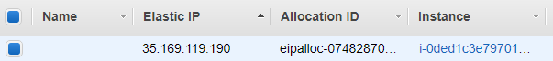

8. In a terminal window, Use the ping utility to ping the new EIP. If you successfully ping, it means the EIP was associated with your EC2 instance:

$ ping <Elastic_IP_Address>

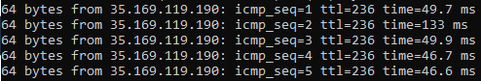

*Reminder*: Use *Control-C* on Windows or *Command-C* on a Mac to stop the ping test.

**Summary**

In this Lab Step, you allocated an Elastic IP Address and associated it with your EC2 instance.